Midnight Blood

Game Design Document

v 1.0

Change Log

|  |  |  |
| --- | --- | --- |
| 13/11/20 | V1.0 | First Draft / Design |

# Table of Contents

## Overview

* Elevator Pitch
* Game Overview
* Setting Overview
* Selling Points

## **Gameplay**

* Core Mechanics
* Dynamics
* Controls
* Game Loops

## **Look & Feel**

* Mood Board
* Art Influences
* Audio Influences
* Mechanic Influences

## 

## **Scope and Resources**

* Team Members
* Scope Overview
* Milestones
* Marketing

# **GAME OVERVIEW**

|  |  |
| --- | --- |
| **Genre** | Horror |
| **Platform** | PC |
| **Point of View** | First Person 3 Dimensional |
| **Theme / Mood** | Moody, gothic, tense. |
| **Target Audience** | Pre-Teen through to Adult casual game audiences |

### **Elevator Pitch**

### 

“You are a vampire.

Each night you wake and stalk the streets,

in search of victims to replenish your energy.

Be stealthy and don’t alert your prey or you might get caught.

When the church bell tolls, retreat before the sun rises,

or it’s game over. How long can you survive?”

### 

### **Game Overview**

* You are a vampire. You wake every night in an abandoned church.
* You must feed by killing villagers or you will starve. This is shown by an energy meter that diminishes over time. It increases with each kill. If the energy meter runs out, game over.
* You can only attack your victims from behind. If you are seen, your prey will be alerted.
* Once a villager is alerted, they will run away from the player and authorities will appear from that direction and attempt to intercept you.
* If the authorities catch you, you will die. React quickly enough and you can escape at the expense of some precious energy.
* When the church bell tolls, the sun is rising.
* Race back to the safety of your crypt to complete the night.
* Survive as many nights as you can.

**Setting: Victorian Gothic Town: Carpathian Mountains (1880s)**

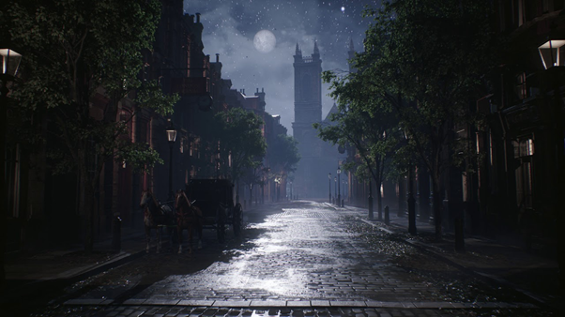

* A dark and moody forest of pine trees encircle a small town of Victorian Gothic houses.
* The streets are narrow and covered with cobblestones.
* At night, the air is thick with fog.
* The houses are all tall with peaked roofs and ornate edges.
* At night, wolves roam the forest, howling occasionally. From the town the only sounds are horses and babies and occasionally the rambling of a drunk stumbling home.

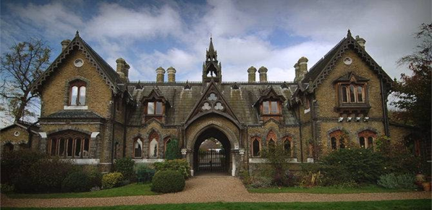

## **Mood Board**

### **Color Palette**

·

### **Location History**

Deep in the wilds of the Carpathian mountains of Romania is a deep dark forest of pine trees. Here the villagers go about their lives mostly like they always have.

### 

### 

### **Level Layout**

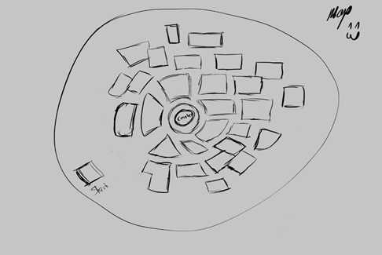

### **Greybox**

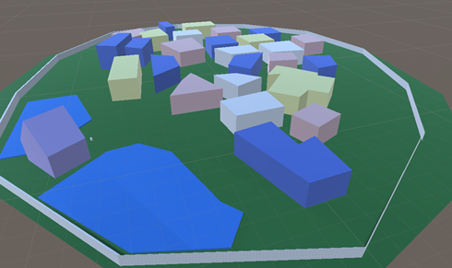

# **GAMEPLAY**

## **Core Mechanics**

### **Navigation: Player Character**

* Standard FPS Input controls
* Cannot jump. Cannot run.
* 8 Meters per second movement.

### **AI: Villager Movements**

* Wander randomly
* Randomly spawned locations and orientations within the town, between buildings.
* Randomly switch between looking around and walking forwards.
* Dynamically react to walking into walls, i.e, turning to not face the wall.
* Villagers will not run from the player until the player’s first kill
* Villagers will potentially encounter the player by random chance.
* Once the player kills the first victim, they will be bloody, and any villagers who see them afterwards will be alerted.
* The alerted villagers will attempt to run directly away from the player/
* Villagers have a maximum player detection distance of 15m, and angle of 80 degrees.

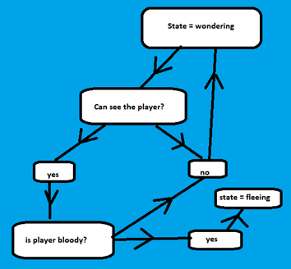

### **AI: Attack Villager**

* The player stalks NPCs. The player adjusts their angle of attack to remain behind the NPC as they get closer.
* At close range, the player can click on the NPC which triggers the feeding action
* Feeding despawns the NPC, adds an amount of energy to the player’s energy meter
* Player feedback includes a sound and a red flash across the HUD
* Player has a attack range of 1-2 meters
* Player must click on the NPC to kill.
* Player receives an amount of energy equal to 25% apon kill.(max of 100%)

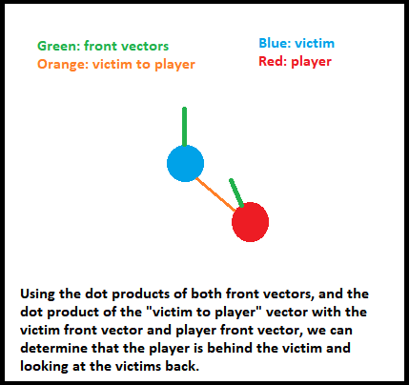

### 

### AI: Enemy

* An alerted NPC will call for help and run away from the player
* After 5 seconds 1 Enemy NPC will be spawned, coming towards the player from the direction and location the NPC is running from
* The Enemy AI will relentlessly chase the player until the player retreats back to the church which will reset the Enemy NPCs

### Sun Timer

### High Scores

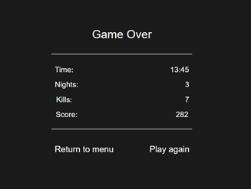

* Player will be given feedback of their progress through the User Interface and HUD
* Player will achieve points for kills and an overall score will be presented at the end of the Level and once the player has died.

·

## 

## **Core Dynamics**

## **Villagers**

* NPCs will wander randomly around the map. They will walk for a few seconds. Stop for a few seconds then walk again.
* They will need to negotiate other NPCs and the buildings
* 15-25 NPCs will be spawned randomly between the buildings, throughout the map each night

## **Authorities**

* Each time a Villager NPC is alerted and runs away from the player, an Enemy AI will be spawned to chase the player
* Once the Authority NPC has been spawned, the Villager NPC will go back to wandering
* The Authority will be faster than player.
* spawned who will chase the player until they retreat back to the church or are caught

## **Energy Conservation**

* Energy ticks down at a constant rate while playing. (e.g, 0.25 energy per second)
* The diminishing energy meter provides motivation for the player to take risks
* Each night, player loses energy equal to 25% of current energy. (i.e, if player goes to crypt with 80 energy, they will spawn the next night with 60.)
* Player spawns on first night with 50% energy.
* Energy is a decimal value between 0 and 100.

## **Successful Attacks**

* Successfully stalking a victim increases the player’s energy and contributes to a tally of kills for the score board.
* Successful attacks are achieved by remaining roughly behind the NPC
* If NPC has seen the player and began to run away, attacks will be much harder or impossible.
* Player must be looking at the NPC hitbox and be within about 1 meter to attack.

### **Unsuccessful Attacks**

* The intended victim will run away calling for help. This will spawn enemies that will chase the player
* Once the player has killed their first victim any villager the crosses line of sight + field of view + visual range of the player will run away.
* Each villager that becomes alerted and runs away will spawn an authority NPC who will relentlessly chase the player until the player retreats back to the church
* This will sometimes mean that there are multiple uthority , just one Authority NPC will force the player back to their spawn.

### **Rising Sun Countdown**

* A timer will countdown the time remaining until dawn.
* Each round is approximately **3-5 minutes**. Exact value will depend on play testing.
* When the timer only has **20 seconds** left, the church bell will toll and the screen will start to brighten.
* The player must return to the church before the time is up or game over.

### 

### **High Scores**

* Giving the player feedback on their performance, motivating them to play again and achieve a higher score.
* High scores will be recorded per playthrough and not stored on file, unless there is time to implement saving of high scores to a file.
* Scores are a combination of kill count and how much time the player has spent in the town.

## 

## **Controls**

· Standard First Person Shooter controls

o Keyboard and Mouse (WASD) + Arrows

o Game controller (console controller) if we have time.



## **Gameplay Loops**

### **Moment to Moment Loops**

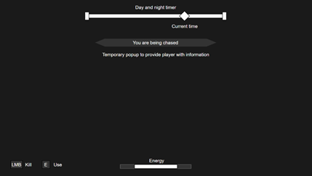

* · Explore world
* · Look for a suitable target
* · Attack to increase energy
* · Evade capture

### **Level Loops**



* · Kill as many villagers as you can while evading capture
* · Make sure you’re back to safety before the sun rises

### 

### **Game Loops**



* · Begin with limited energy
* · Complete as many nights as possible
* · Achieve high scores

**References**



## **Prototyping Plan**

#### Stage 1

* Player Navigation – Andrew
* User Interface / Scoring - Sam
* NPCs - Fred
* Scaffolding – Sam / Grant
* Map - Grant
* Lives / Levels / Timers – Sam / Grant
* Day / Night Cycle - Grant

#### Progress Report

#### Debugging Report

#### User Testing Feedback

## 

## **Scope and Resources**

### **Team Members**

#### **Programming:**

* Fredrick Bancan
* Sam Nagy
* Andrew Osborn

#### **Art:**

* Jamie Appleby
* Sarah Hocking
* Mark Hanks

#### **Production:**

* Grant Bailey

### **Scope Overview**

* Contained map - 200m x 200m
* Modular parts for 6 distinct buildings
* 1 church hero model
* No Player model
* 1 NPC model, 3 Textures… Male, Female, Authority
* Minimal NPC animations and states
* 4 Canvas Screens: Menu, Pause, Level Complete, Game Over
* Minimal HUD, widgets and special effects if we have time

## 

## **Milestones**

* Pre-Production (2nd – 13th November)
  + o Group Pitch Approval
  + o Documentation
    - Game Design Document (v1.0)
    - Technical Design Document (v1.0)
    - Art Bible (v1.0)
  + Greybox (11th 16th November)
    - Greybox Level
* Production
  + Alpha (17th – 27th November)
    - Alpha Level Build
    - Feature Complete
  + Beta (27th November – 2nd December)
    - Beta Level Build
    - All Artwork and Effects
    - Testing and Polish
  + o Gold (2nd December – 4th December)
    - Gold Build
    - Game Design Document (Final)
    - Technical Design Document (Final)
    - Art Bible (Final)

### 

### **Marketing**

* Product will be marketed through:
  + AIE
  + Team members’ portfolios
  + Team members personal networks.